Url Slug Suggestion - https://rootcabs.com/services/local-taxi
Primary Keyword

local taxi service
local cab service
Secondary Keyword

Local Taxi
local taxi near me
local taxi service near me
local cabs near me
local cabs
nearest taxi service
local cab service near me
local cab service
local taxi cab
local airport transfers
local cabs in my area
book local taxi
taxi hire near me
outstation taxi service near me
8 seater taxi hire near me
nearest taxi service near me
local taxis near my location
book a local taxi
24 hours taxi service
call local taxi
Page Layout


Include the keyword taxi service, taxi service in madurai in the header.
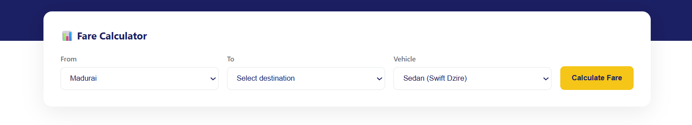
Explain the service that currently works in madurai.

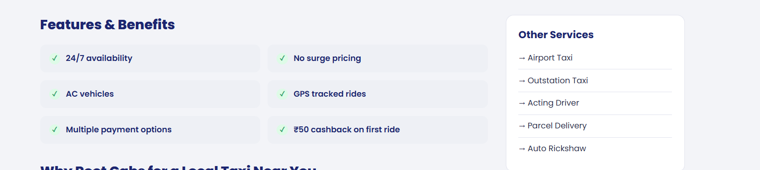

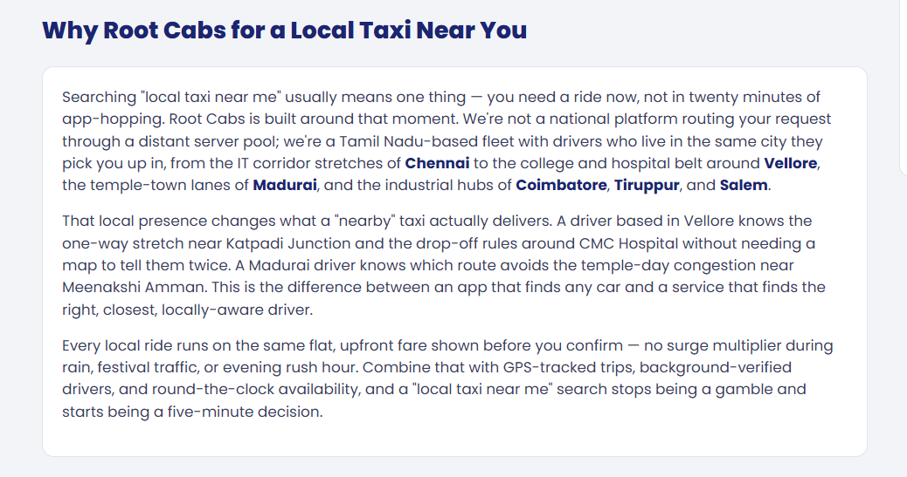

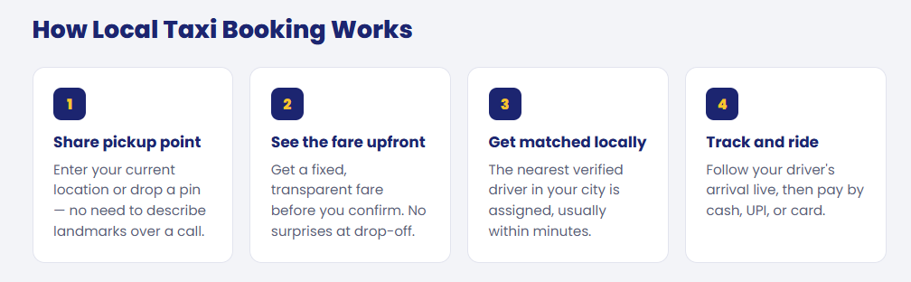

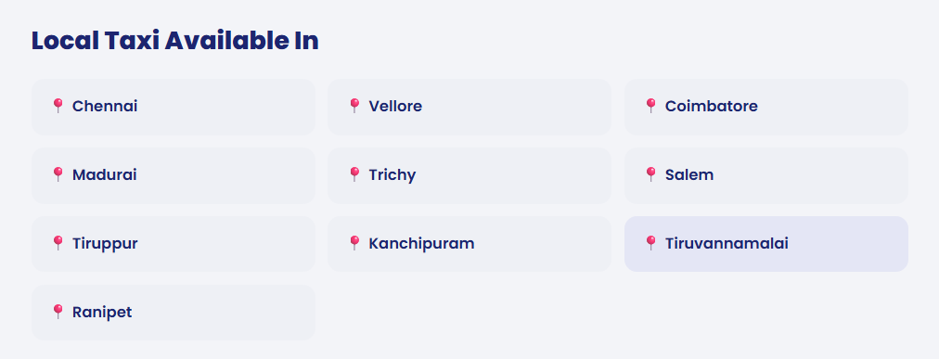

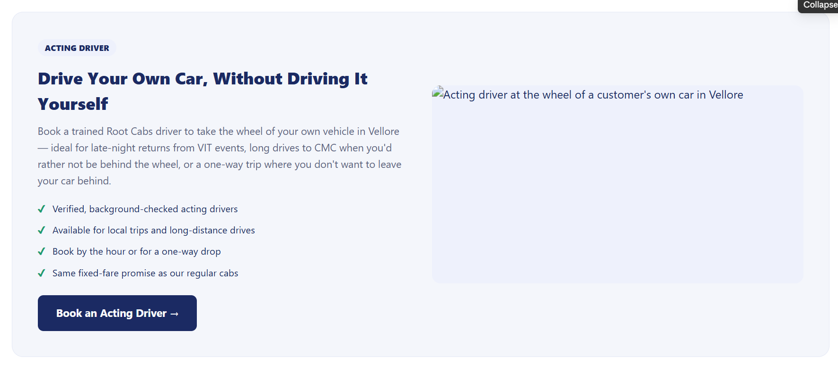

Acting driver section added - Purpose interlinking to the acting driver page.

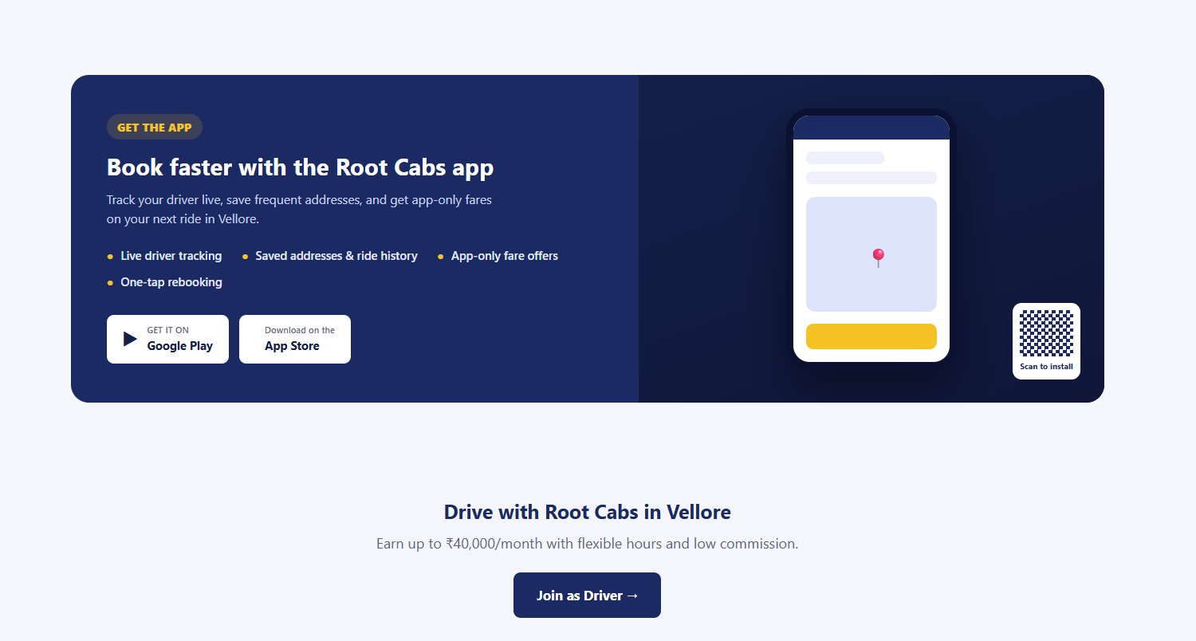

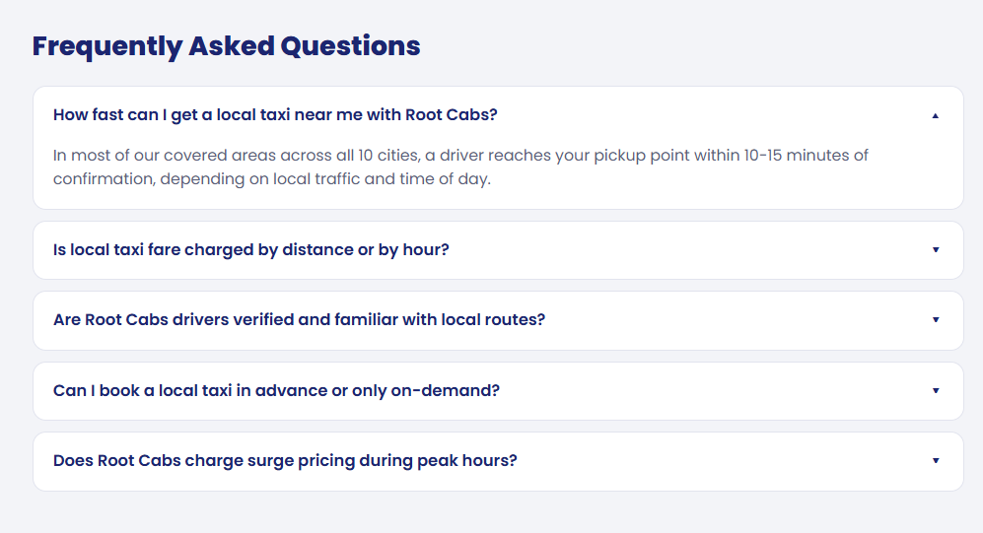
How much for a 1 km taxi?
Does Root Cabs charge surge pricing during peak hours?
How fast can I get a local taxi near me with Root Cabs?
Is local taxi fare charged by distance or by hour?
Are Root Cabs drivers verified and familiar with local routes?
Can I book a local taxi in advance or only on-demand?
Are there extra charges if the driver has to wait for me?

